App & Web Server Setup Using Nginx, Apache, Tomcat & HAProxy on Linux (via Git Bash / SSH)

1️⃣ Install Nginx and Run on Port 81

Install Nginx

sudo apt update
sudo apt install nginx -y

Change Nginx Port to 81

sudo nano /etc/nginx/sites-available/default

Change:

listen 80 default_server;

To:

listen 81 default_server;

Restart Nginx:

sudo systemctl restart nginx
sudo systemctl status nginx

Verify

Browser:

http://<SERVER_IP>:81

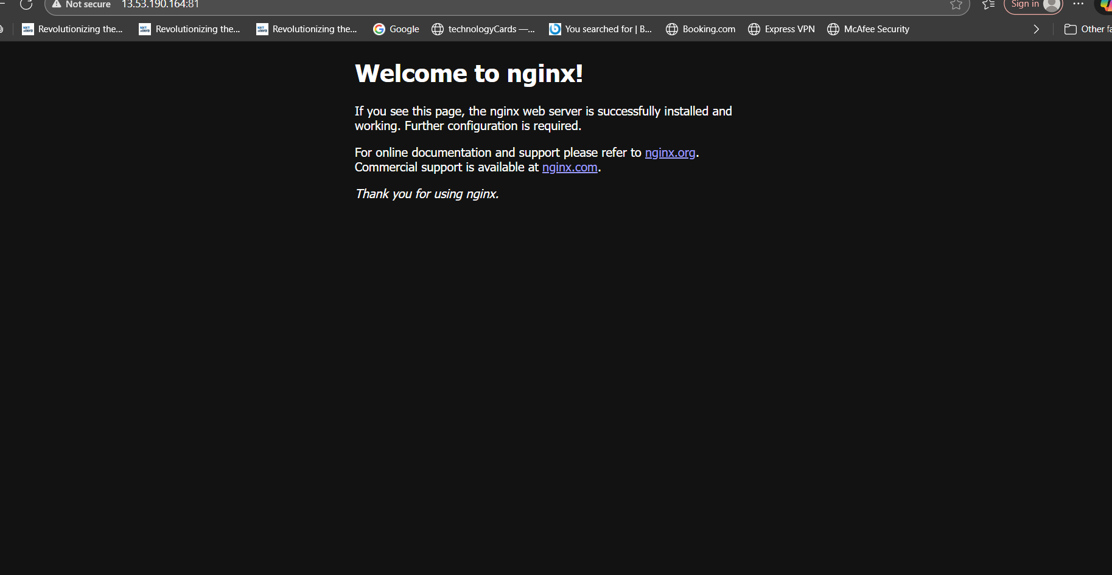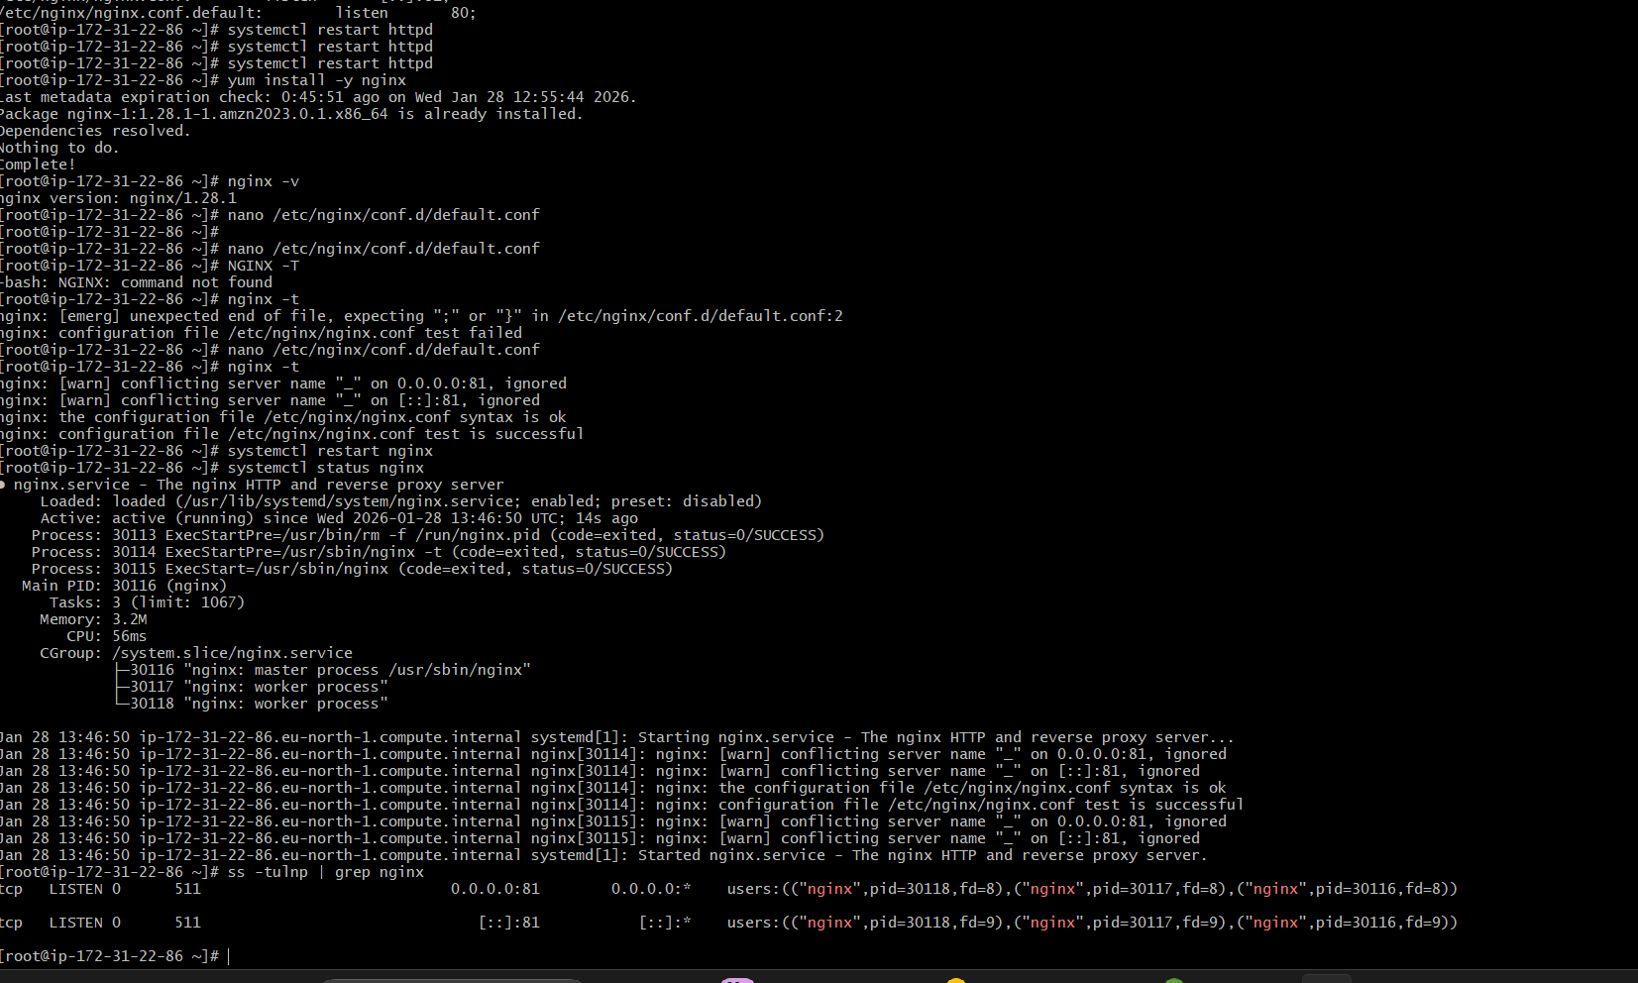

2️⃣ Deploy Sample index.html on Nginx

sudo nano /var/www/html/index.html

Paste:

<h1>Welcome to Nginx on Port 81</h1>

Reload Nginx:

sudo systemctl reload nginx

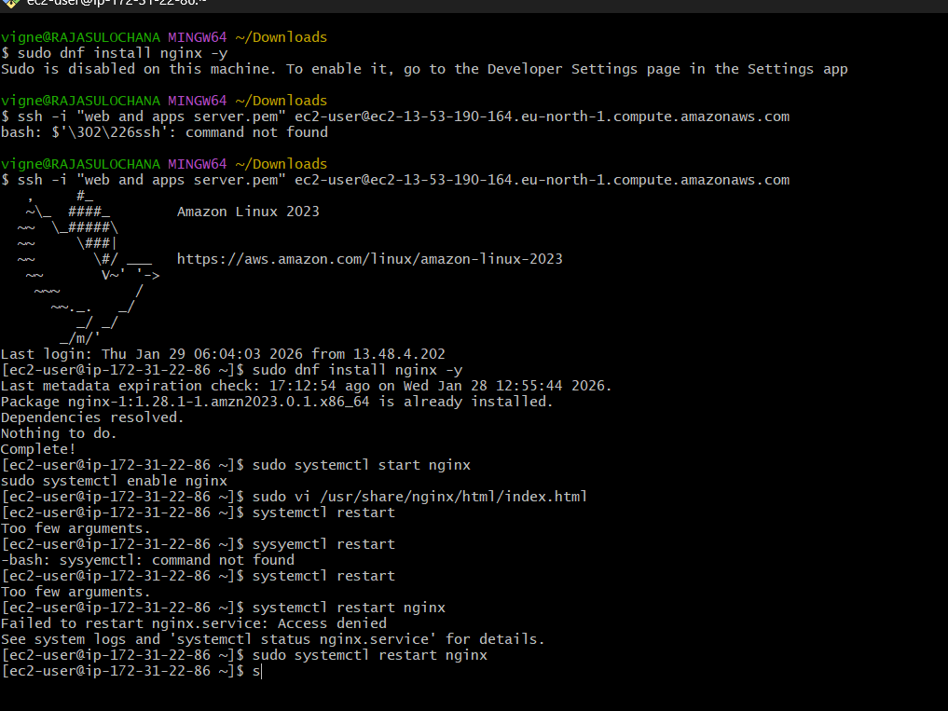

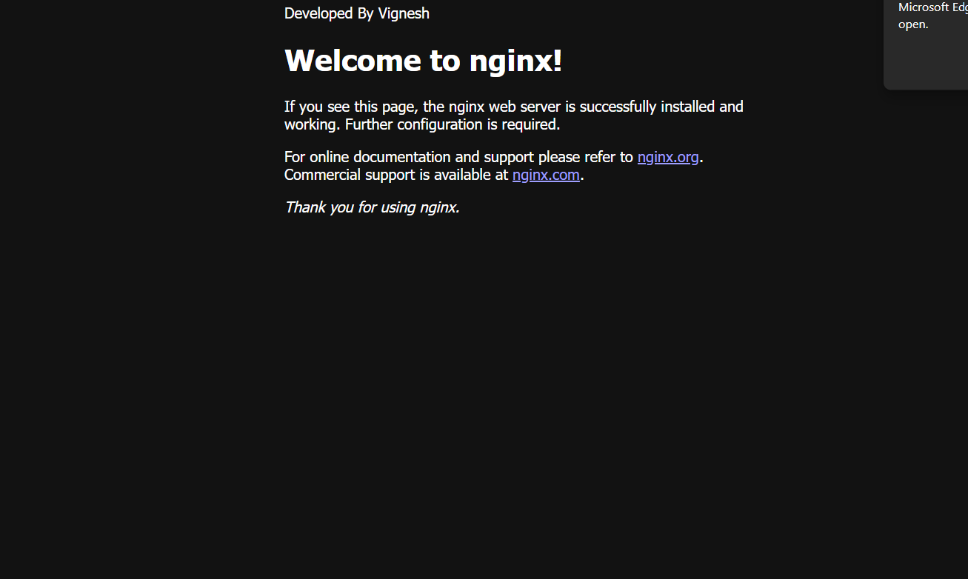
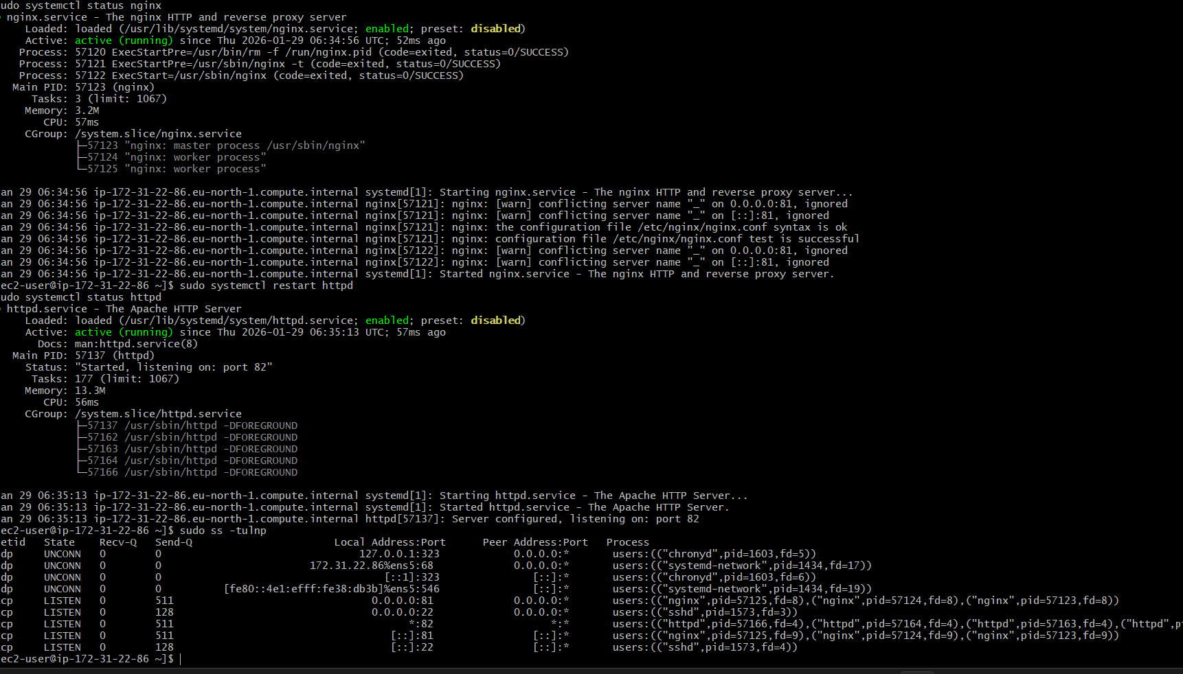

3️⃣ Install Apache and Run on Port 82

Install Apache

sudo apt install apache2 -y

Change Apache Port

sudo nano /etc/apache2/ports.conf

Change:

Listen 80

To:

Listen 82

Edit Virtual Host:

sudo nano /etc/apache2/sites-available/000-default.conf

Change:

<VirtualHost *:80>

To:

<VirtualHost *:82>

Restart Apache:

sudo systemctl restart apache2

Verify

http://<SERVER_IP>:82





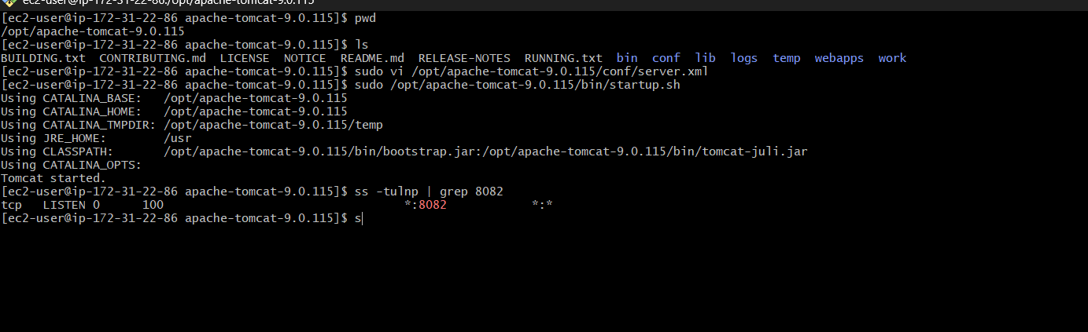
4️⃣ Deploy Sample index.html on Apache

sudo nano /var/www/html/index.html

Paste:

<h1>Welcome to Apache on Port 82</h1>

Restart Apache:

sudo systemctl restart apache2
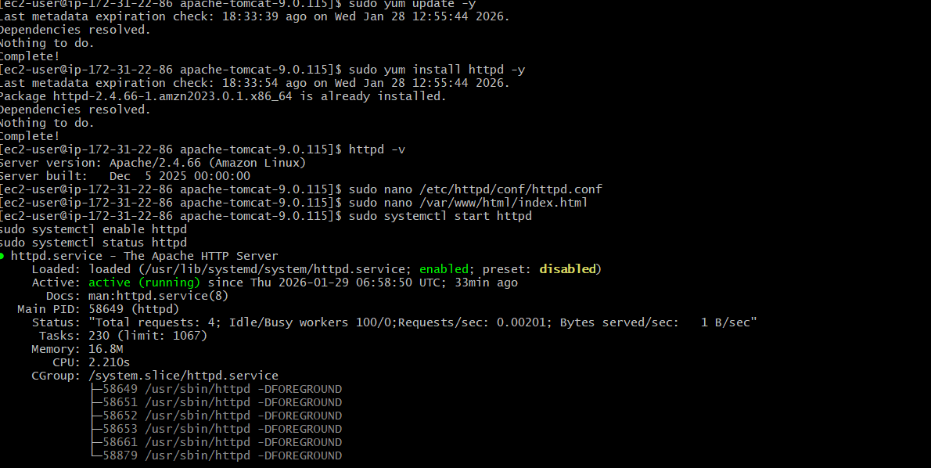

5️⃣ Install Apache Tomcat on Port 8082

Install Java

sudo apt install openjdk-11-jdk -y

Download Tomcat

cd /opt
sudo wget https://dlcdn.apache.org/tomcat/tomcat-9/v9.0.85/bin/apache-tomcat-9.0.85.tar.gz
sudo tar -xvzf apache-tomcat-9.0.85.tar.gz
sudo mv apache-tomcat-9.0.85 tomcat

Change Tomcat Port

sudo nano /opt/tomcat/conf/server.xml

Change:

Connector port="8080"

To:

Connector port="8082"

Start Tomcat:

/opt/tomcat/bin/startup.sh

Verify

http://<SERVER_IP>:8082

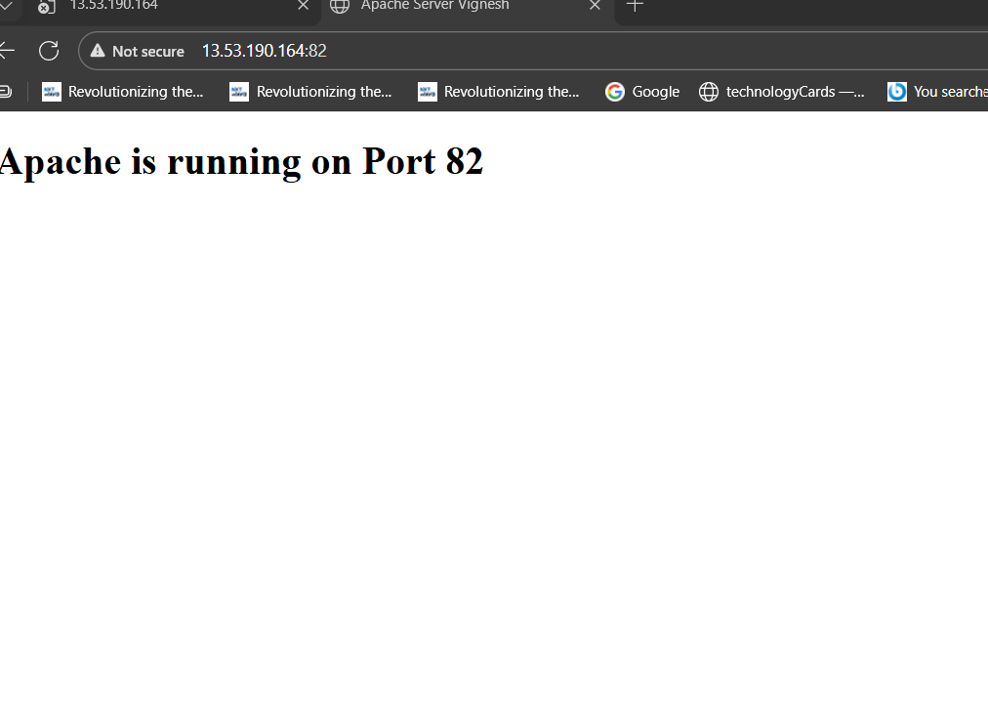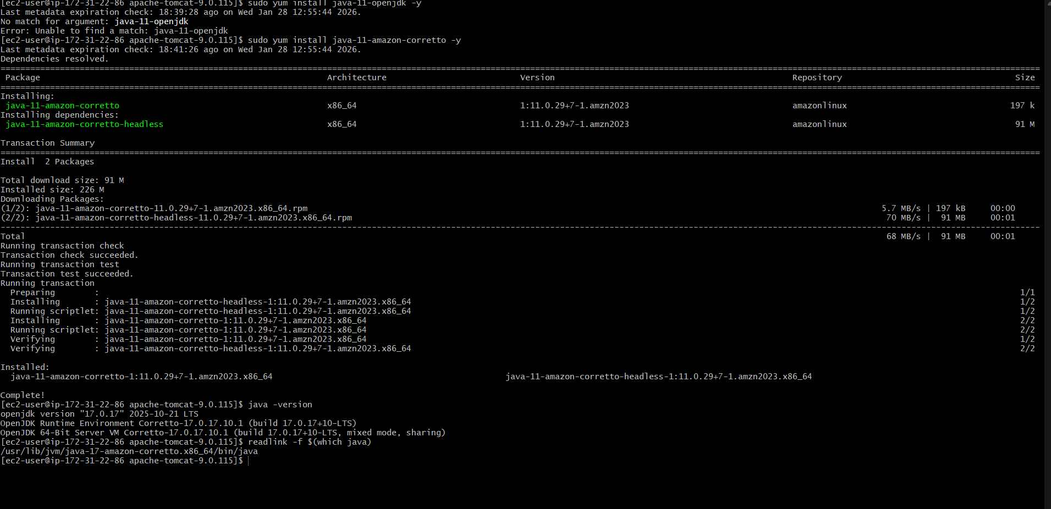

6️⃣ Deploy Sample App on Tomcat (webapps)

cd /opt/tomcat/webapps
sudo mkdir sampleapp
sudo nano sampleapp/index.jsp

Paste:

<h1>Welcome to Tomcat Sample App</h1>

Restart Tomcat:

/opt/tomcat/bin/shutdown.sh
/opt/tomcat/bin/startup.sh

Verify:

http://<SERVER_IP>:8082/sampleapp

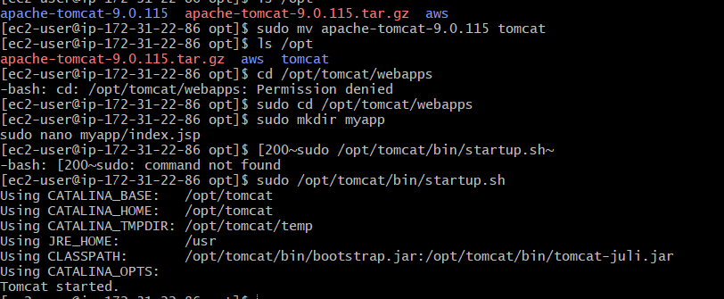

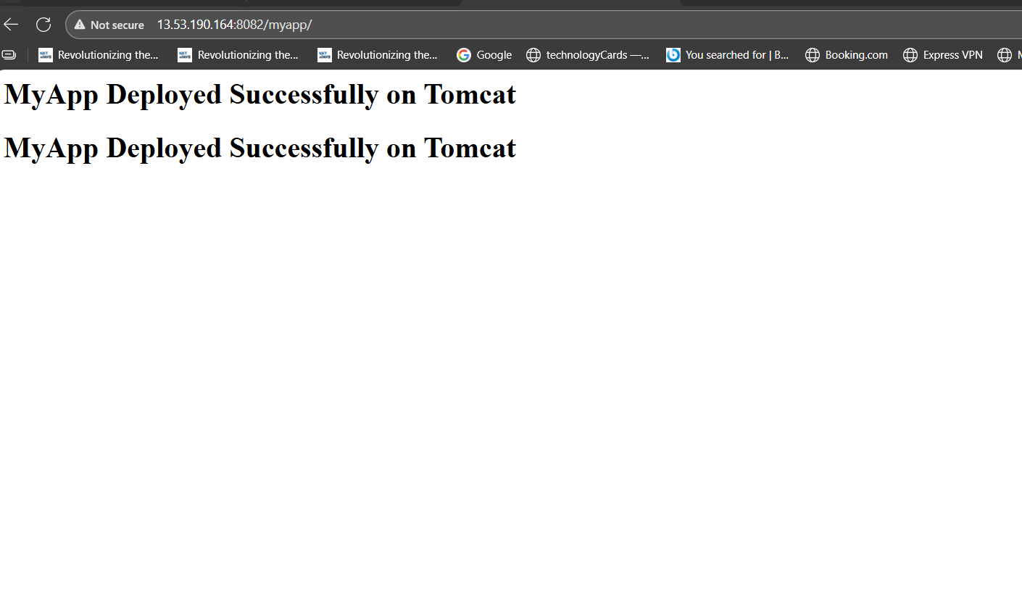

7️⃣ Create tomcat.service File

sudo nano /etc/systemd/system/tomcat.service

Paste:

[Unit]
Description=Apache Tomcat
After=network.target

[Service]
Type=forking
ExecStart=/opt/tomcat/bin/startup.sh
[Service]
ExecStop=/opt/tomcat/bin/shutdown.sh
User=root
Group=root

[Install]
WantedBy=multi-user.target

Reload and start service:

sudo systemctl daemon-reload
sudo systemctl enable tomcat
sudo systemctl start tomcat
sudo systemctl status tomcat

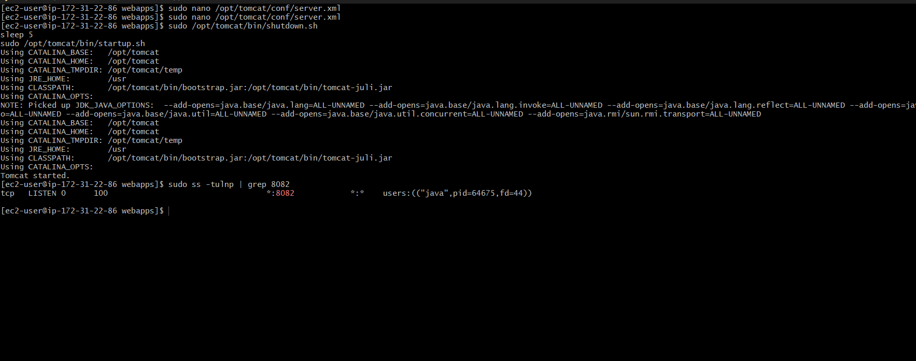

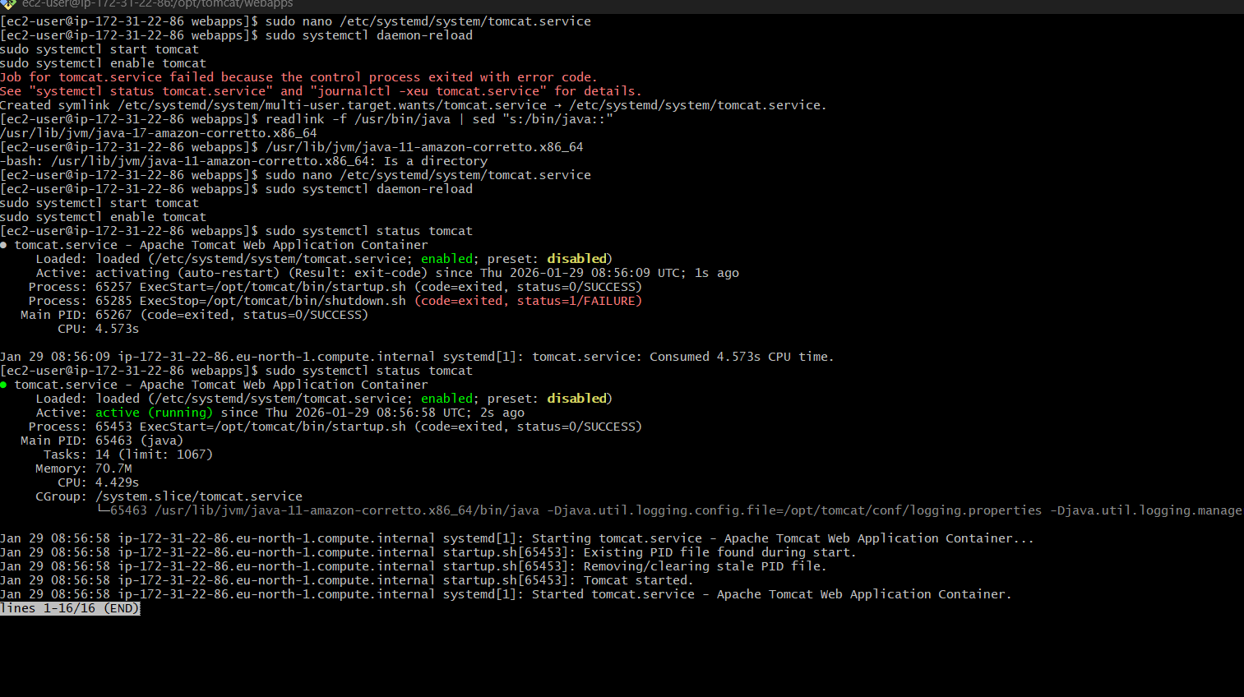

8️⃣ Configure HAProxy Server

Install HAProxy

sudo apt install haproxy -y

Configure HAProxy

sudo nano /etc/haproxy/haproxy.cfg

Add at bottom:

frontend web_frontend
bind *:80
default_backend web_backend

backend web_backend
balance roundrobin
server nginx_server 127.0.0.1:81 check
server apache_server 127.0.0.1:82 check

Restart HAProxy:

sudo systemctl restart haproxy
sudo systemctl status haproxy

Verify Load Balancing

Browser:

http://<SERVER_IP>

✅ Final Verification Checklist

Nginx → Port 81 ✔

Apache → Port 82 ✔

Tomcat → Port 8082 ✔

Sample apps deployed ✔

Tomcat systemd service ✔

HAProxy load balancing ✔

Reload and start service:
```bash
sudo systemctl daemon-reload
sudo systemctl enable tomcat
sudo systemctl start tomcat
sudo systemctl status tomcat
